SEO META-DATA

EXAMPLE

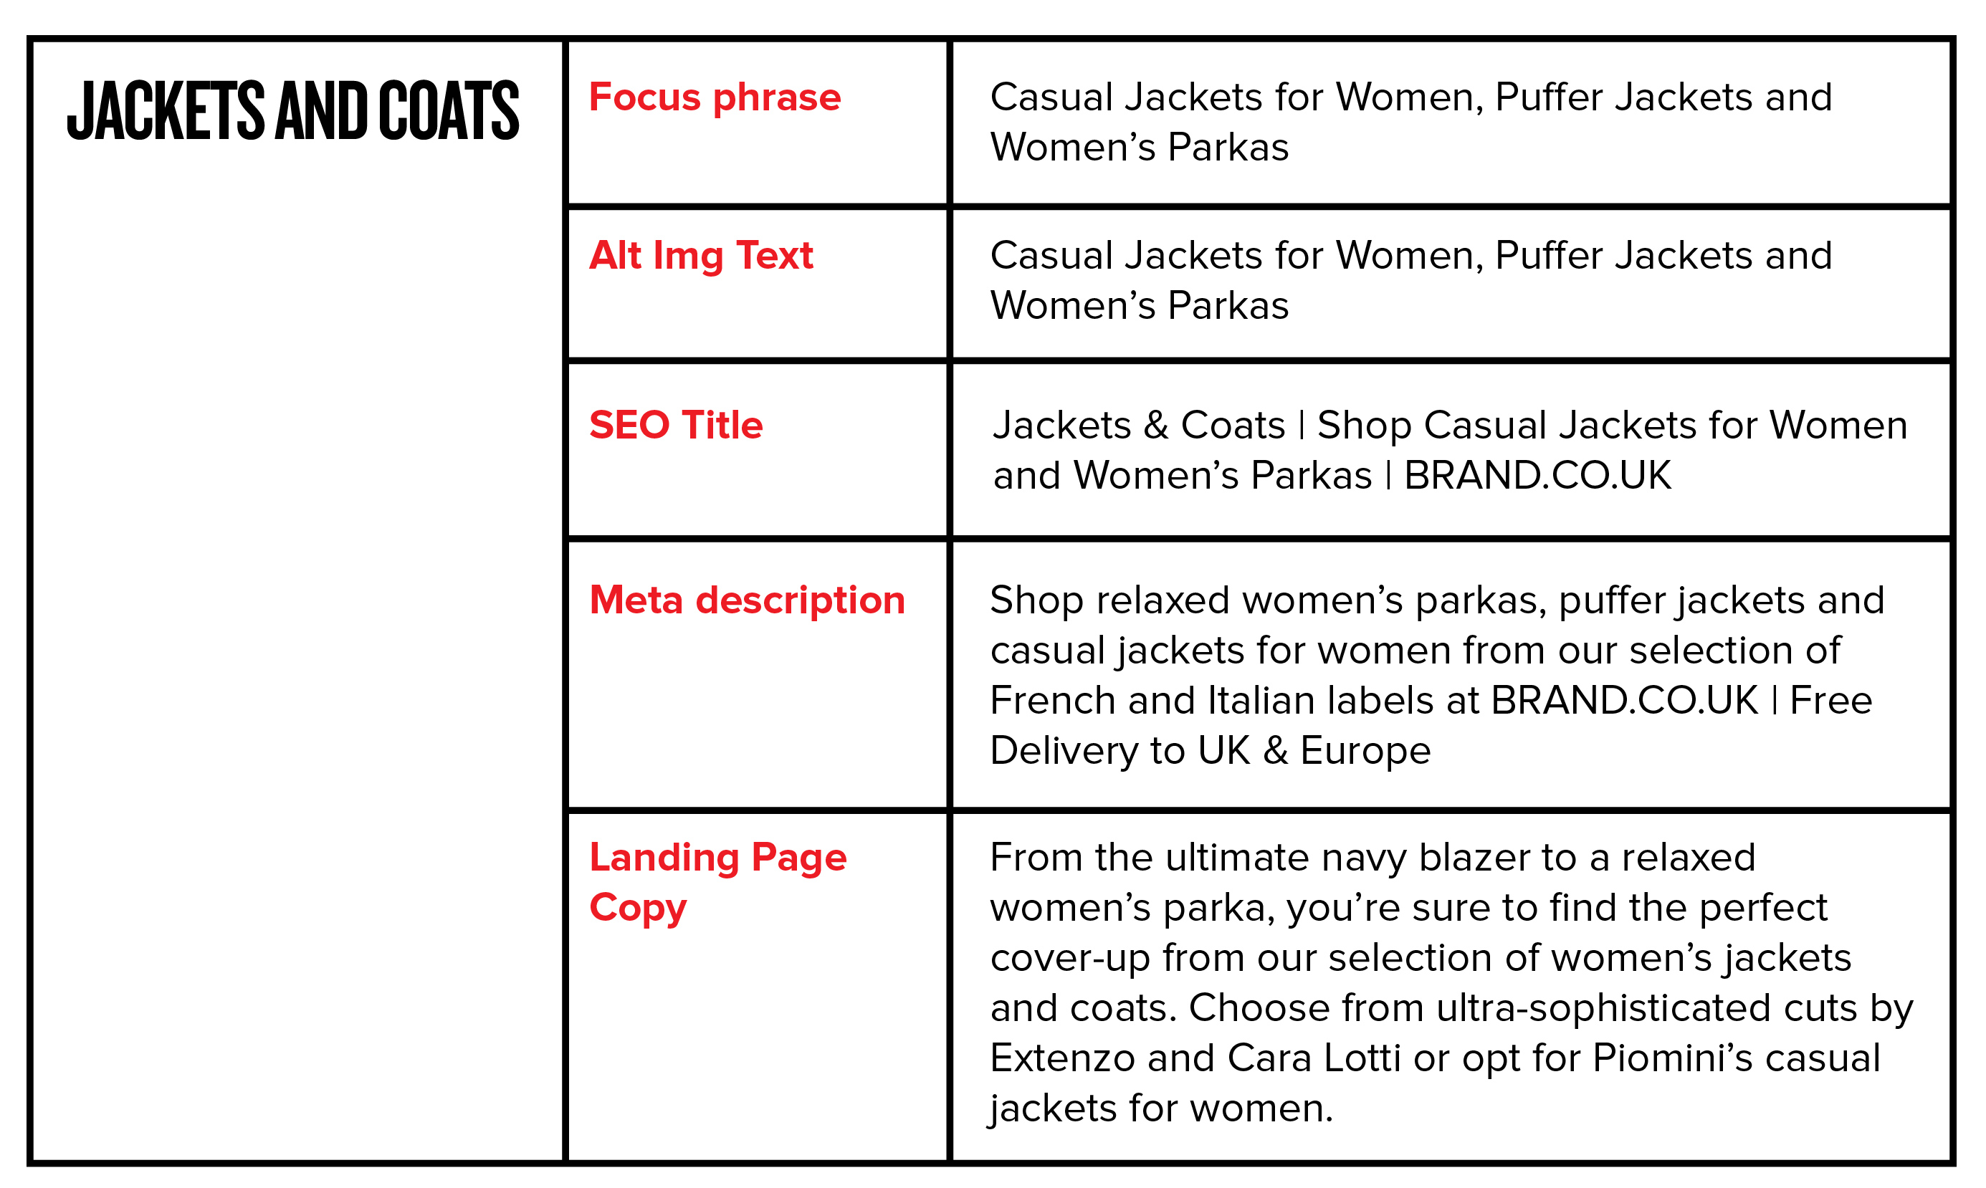

Important Information

SEO Title: No more than 43-55 Characters
Meta Description: No more than 156 Characters

The below examples are of a category or main tab on a website.

Category Name: [Swimwear]
Focus Keywords: Decide on the exact keywords for this category
Alt Text Keywords (Image): [Focus keyword phrase]
SEO Title: [Focus keyword phrase] + [Company Name]
Meta Tag Description: [Focus keyword phrase] + [Tell a story about the page] + [Call to action]
Landing Page Description: [Focus keyword phrase] + [Tell a story about the page] + [Add more detail]

Two Examples

Bathroom Suites
- Focus Keyword/Phrase – Bathroom Suites
  - Alt text for Image – Bathroom Suites
- SEO Title – Bathroom Suites I Deals On Bathrooms
- Meta Description – Luxury Designer, Compact and Traditional bathroom suites available throughout the UK. Buy now from Deals On Bathrooms

Garden Ideas
- Focus Keyword/Phrase – Garden Ideas
  - Alt text for Image – Garden Ideas
- SEO Title – Garden Ideas I GardensRUS.co.uk
- Meta Description – Garden design ideas for your home and office garden, small or large get this free download now from GardensRUS.co.uk

